## EXPERIMENT 4: Using TraceRoute, ping, ifconfig, netstat Command

**Step 1**: Type tracert command and type [domain name pr](http://www.prestashop.com/)ess “Enter”.

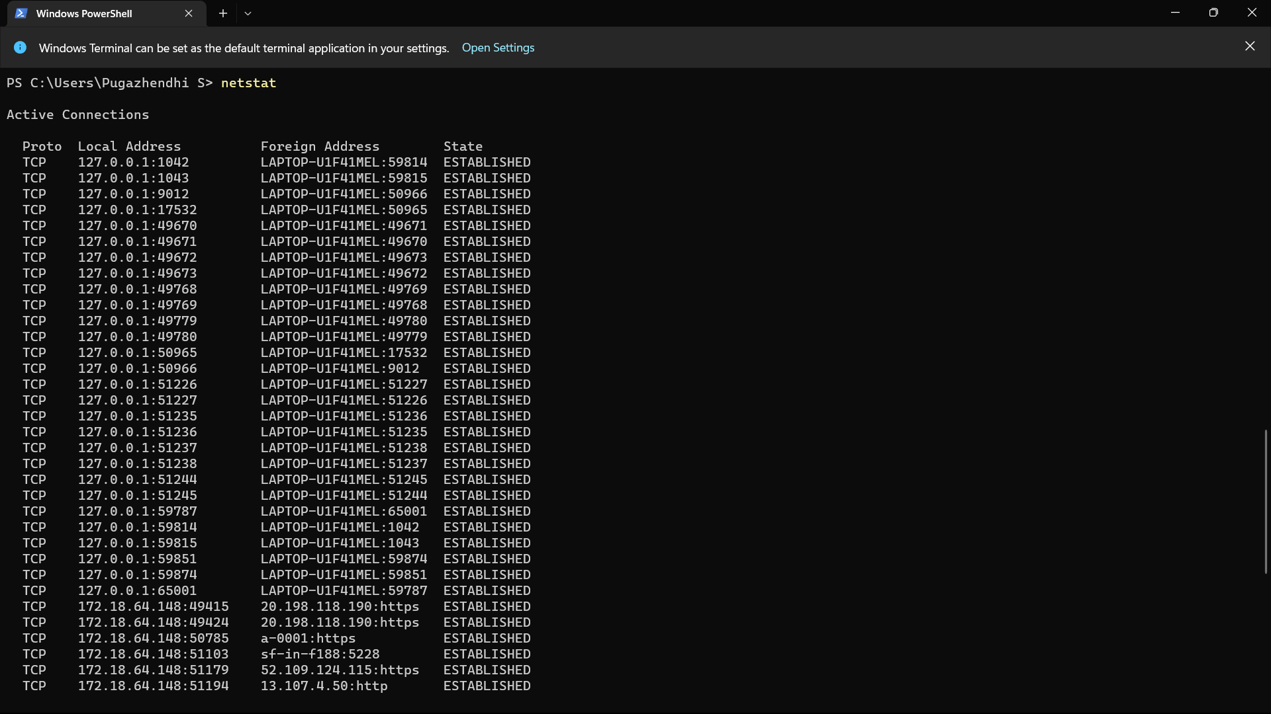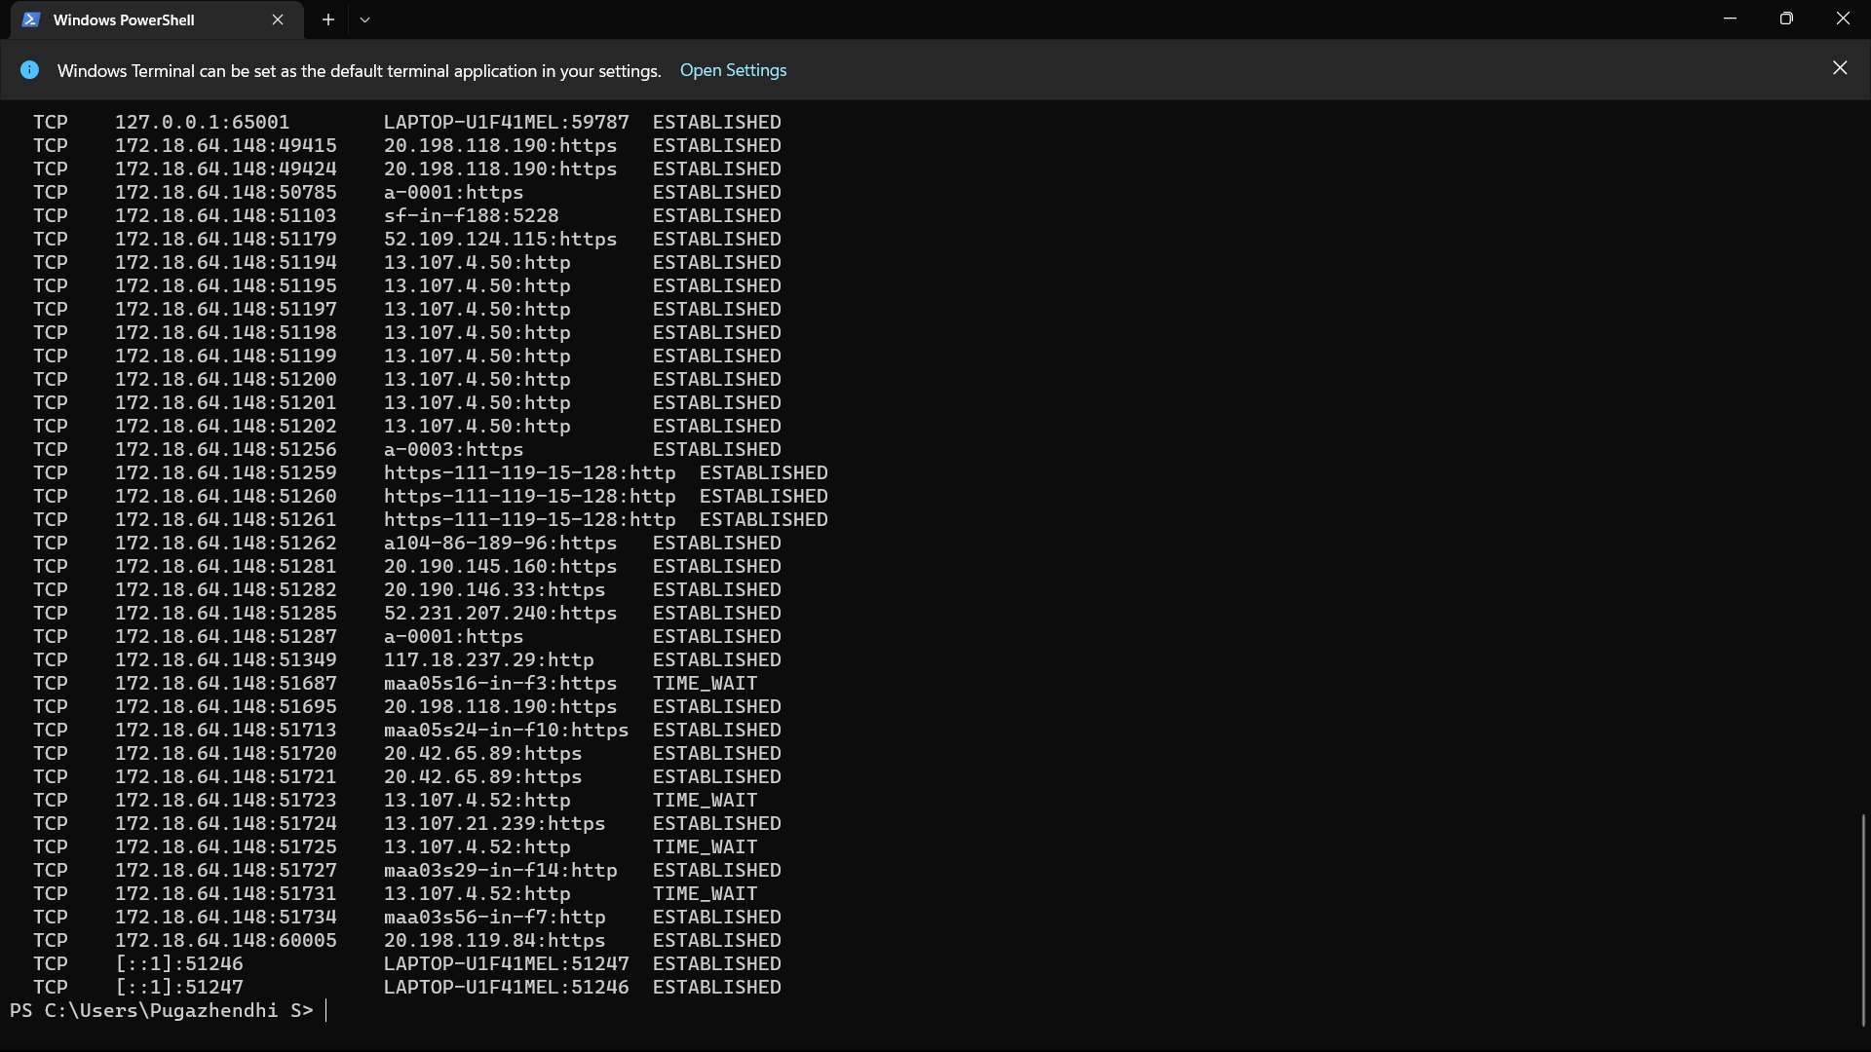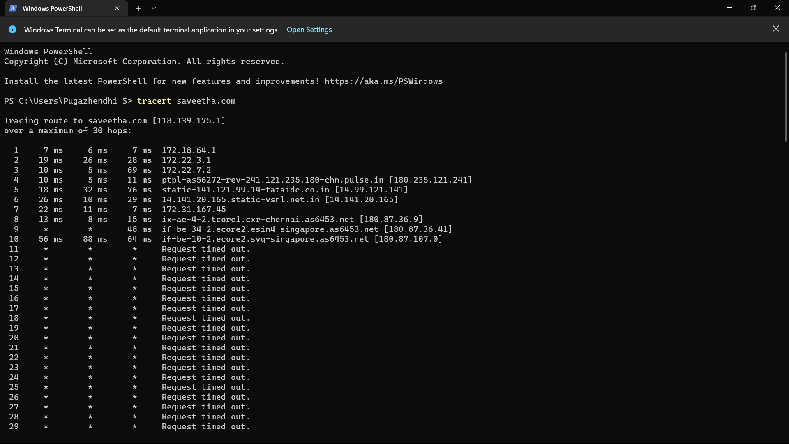

**Step 2**: Ping all the IP addresses

